Pneumatic Bourke Engine

University of Sydney

Aidan McDaid

Dr. Andre Kyme

**Purpose**

The inspiration for this project started from a YouTube video that demonstrated a certain style of pneumatic actuation (<https://www.youtube.com/watch?v=BBG-8ZSOmdY>). From this video, I developed my project to reverse engineering this motor in order to create a similar form of actuation that would be MR compatible. The hope was to be able to use this actuation as a part of a larger project of developing a mechanical phantom that could simulate motion in an MRI.

**Goals**

The goals of the project were to create a pneumatic motor with the design of a Bourke Engine as seen in Figure 1. With limited resources, one goal was that the motor had to be relatively cheap so that it could be manufactured and replaced easily. Another goal was that the motor had to be MR compatible so that it had the potential to be used in an MRI in the future. The motor had to be pneumatic meaning that it ran on compressed air allowing for MR Compatibility, clean actuation, low maintenance, and an easily accessible compressed air supply. Some of the other goals were that the motor had to be relatively small, scalable, and have rotary motion.



**Figure 1:** Bourke Engine Design

**Theory/Application**

The theory and behind the project was basically a proof of concept where this design could be used and refined for many different applications. These applications could be anything from a moving phantom in an MRI to real time surgeries conducted in an MRI using this actuation as the main motion source. The next step was to apply these goals in an actual prototype which was manufactured using the materials and methods as follows.

**Materials**

|  |  |  |
| --- | --- | --- |
| Part | Quantity | Purpose |
| ABS filament | NA | This was used in the 3D printer as the base material for the entire motor |
| 3D Printer | 1 | Used to procure most of the structural parts of the motor |
| Silicone sheeting | 1 | Used as gaskets for Motor pistons |
| Nylon screws/nuts/washers | 30 | Fastened the different parts of the motor |
| Silicone Lubricant | 1 | Lubricated the crank shaft of the motor |
| Plastic Piping | 4 | Connected compressor to motor |
| 24 V Power supply | 1 | Powered the Arduino and valves |
| 5/2 way air valve | 2 | Controlled by Arduino and distributed air at precise times to cause rotation |
| Arduino | 1 | Controlled Valves |
| Arduino Relay | 1 | Controlled Valves |
| Air compressor | 1 | Provided compressed air supply |
| Compressor couplings | NA | Distributed air uniformly |
| Silicone Sealant | 1 | Used to make gaskets for structural components |

**Manufacturing and Methods**

There were many things that had to be taken into consideration during the building process of this motor so that it can be replicated or continued.

1. **3D Printing**: The structural and functional parts of this motor were created by 3D printing which had many benefits and drawbacks. The most convenient part of this method is being able to design it in a CAD software and printing it at need. This made it easy to make modifications and also consider ones creativity. A drawback to this is that the prints will never be perfect and many factors have to be taken into consideration such as the definition of the print, the slice width, the filling, and the materials. Because of these modifications the prints are often not perfect and cannot create a perfectly air-tight machine, so one must just compromise and settle for an imperfect prototype, and air leakage.
2. **Assembly**:The best way to assemble the motor is by assembling the crankshaft mechanism first and then building the body of the motor around it. It is important to line up all the screws before the nuts are tightened down to ensure proper alignment.
3. **Silicone Seals:** Silicone seals had to be made both on the piston heads as well as between the structural components of the motor. The liquid silicone sealant was used to line the outer rim between the upper and lower body plates to reduce leakage at the meetings of two plates. This is not an essential step but it vastly improves air leakage and performance of the motor. The silicone sheeting was used to create a seal on the pistons so that during a power stroke of the motor, there is minimal pressure loss. This is best achieved when making the seal a slightly larger rectangle than the inner area of the cylinder. Both these seals are very important because reducing leakage is essential to the performance of the motor, however it is very difficult to create a perfect seal with the methods used.
4. **Air Intakes:** The air intakes on each of the pistons of the motor have to be drilled by hand to account for different tubing sizes. The best method is to drill centered holes with a bit slightly smaller than the diameter of the tube to create the best seal on the motor.
5. **Lubrication:** It is important to lubricate any points of friction inside the motor because it will reduce wear on the moving parts of the motor and also ensure smooth actuation.

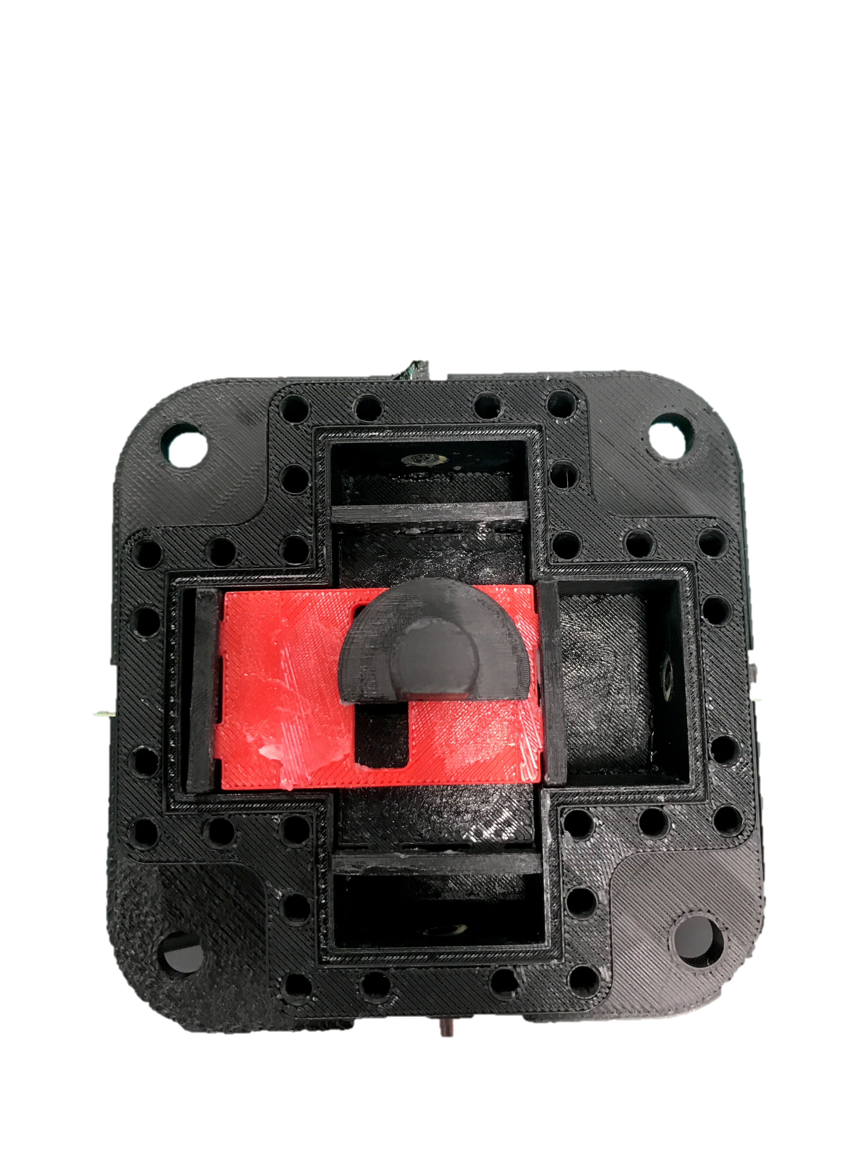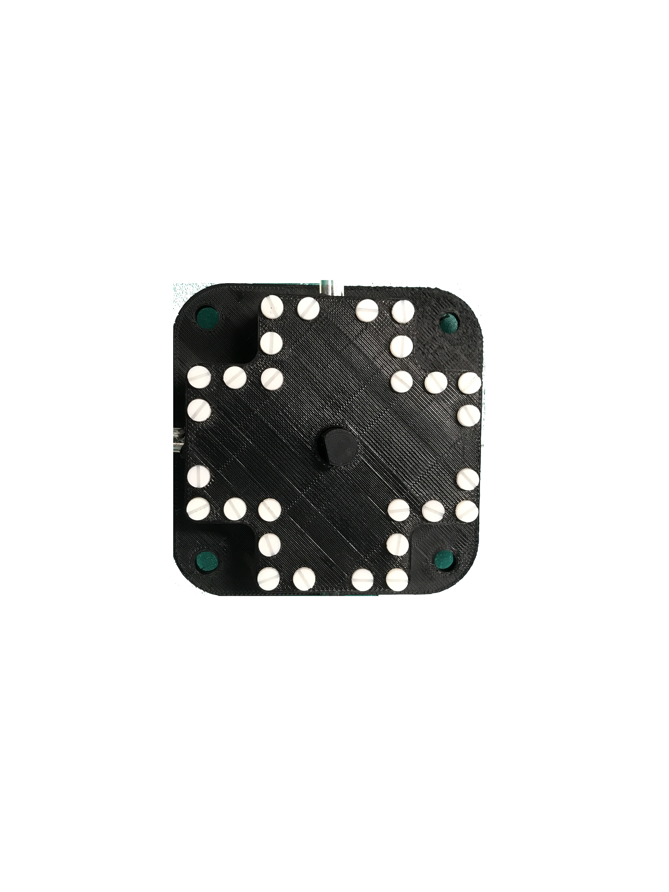

**Figure 2:** Motor Assembly

**Running**

To the run the motor after assemble, the steps are relatively simple in order to ensure proper rotary motion**.** The most important keys to success os to have a correct code to determine the pattern of the relays, and also to hook up the tubes correctly to the valves to ensure proper deliver of air. The code is depicted in figure 3 and the basic concept behind it, is that the delay determines the step time of each stroke, and the shorted the delay, the quicker the motor will function. Additionally, the pin outputs being on or off determines the activity of the relay and therefore the state of the valve. The valves work with the relay programming by having a constant supply of compressed air so that air is flowing through one output on each valve at a time. The proper way to hook up the valves to the motor is to image that each valves output is labeled A and B respectively. By starting with a single piston and moving around the motor CW or CCW, plug in the tubes connected to the valves of A, A, B ,B respectively. By considering this arrangement with the functionality of the code, it is delivering pressure to two valves while two are exhausting at any given time, while it switches one valve at a time. Figure 4 depicts the total arrangement of the motor system to ensure running success.

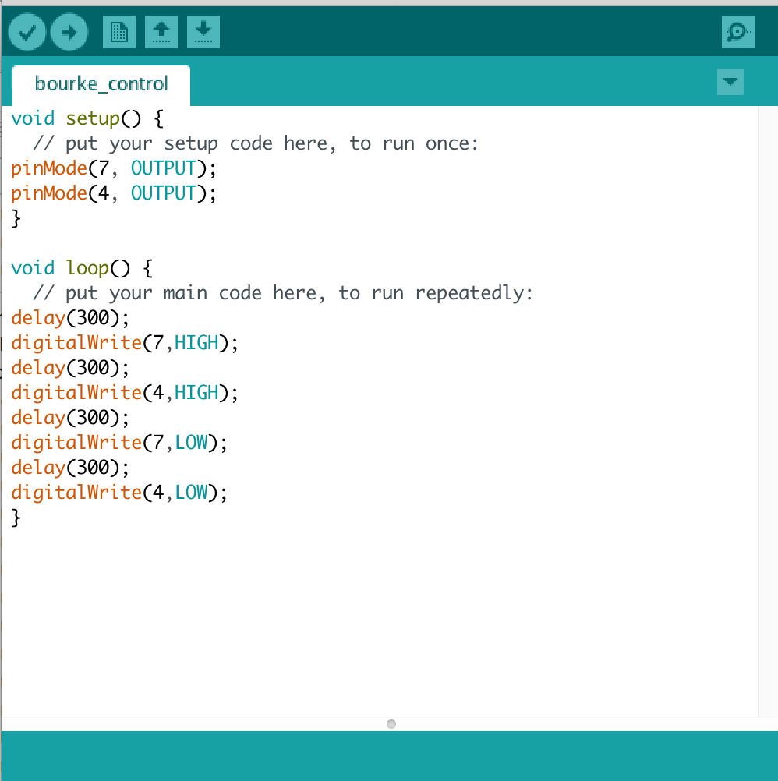

**Figure 3:** Arduino Code with 300 ms step time

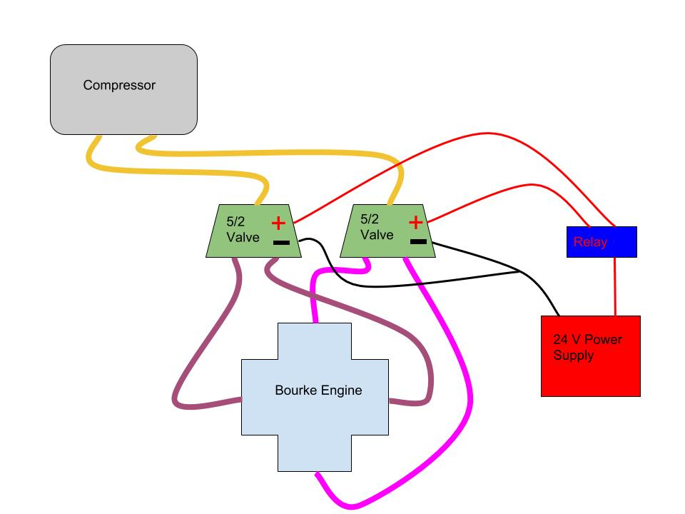

**Figure 4:** Running Motor Assembly

**Testing**

1. **Speed and Torque Test**

The speed and torque test was conducted on the motor by building an apparatus to couple the pneumatic motor with an electric motor that had an encoder on it. This was able to record speed and torque data because the electric motor acted as a generator and the encoder displayed speed data. I was unable to test the maximum load capacity of the motor, but a normal working speed was calculated to be 1.31 rps that produced a torque of 8.24 lb/in. This was calculated by using the data collected from the waveforms below. The next step in this testing field would be to determine the maximum torque output of the motor at a pressure of 2 Bar.

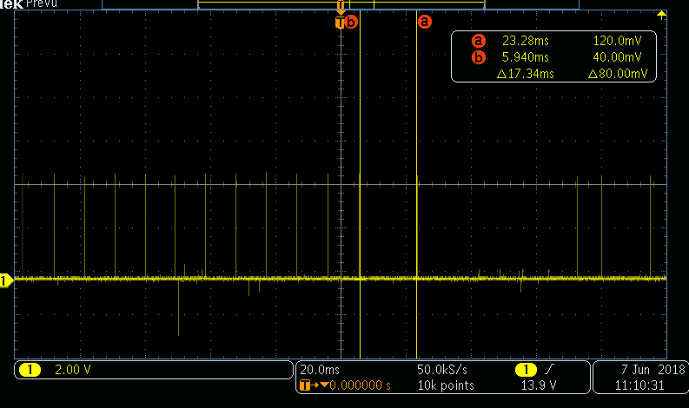

**Figure 5:** Waveform of the speed of the electric motor powered by the pneumatic motor. Using the gear ratio of ~82, the rate came out to 1.31 rps.

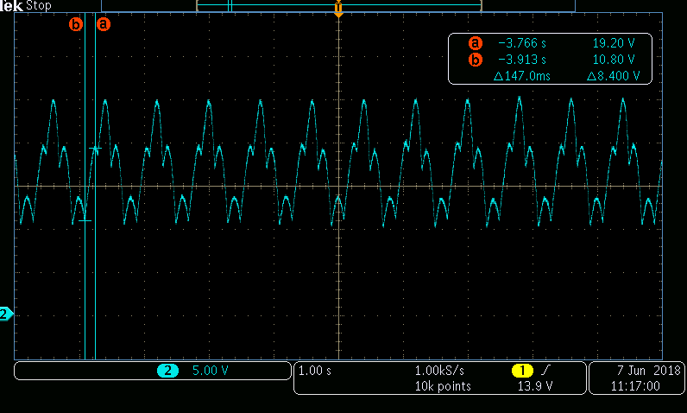

**Figure 6:** Waveform of the voltage produced by the electric motor powered by the pneumatic motor, averaged to be about 18.4 V.

1. **MR Compatibility Test**

The second test that was conducted was an MR compatibility test where the motor was place in a functional MRI that would record and image while the motor was off and then on, and record the image data of a phantom. By making a comparison between the images, the amount of noise generated by the motor can be determined. As seen in figure 7, while the motor was on, it generated virtually no noise and made no disruptions or distortions to the spherical phantom. This was great news for the future of the technology because it proves that completely MR compatible actuation is possible.

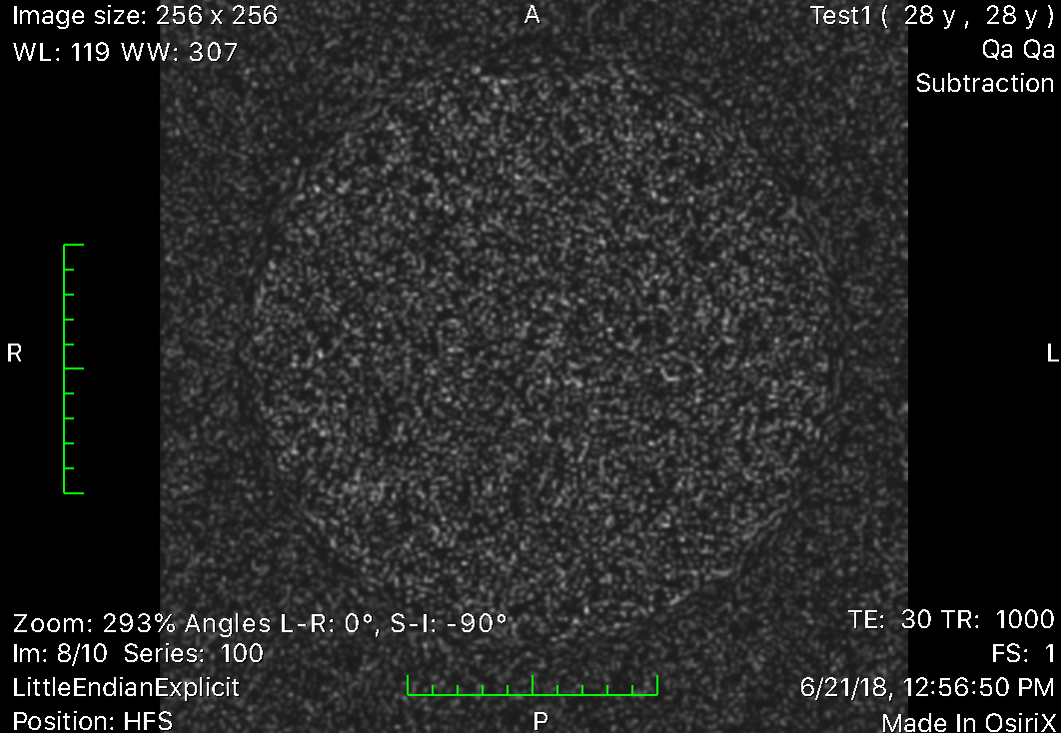

**Figure 7:** This is a DICOM image of the two subtracted images from the motor running in the MRI. The prevalence of black space indicates that the images of the motor running and not running are experimentally identical meaning that the motor produced no noise.

**Results**

In conclusion, the motor turned out to be a very successful proof of concept that had favorable test results. In conclusion these results concluded that the motor is powerful enough to be clinically used and controlled for many applications. Additionally the motor is fully MR compatible so it could be applied to many different mechanisms and replaces the need for electric motors.

**Next Steps**

The next major steps for this project would be to further test the current motor, attempt scaling the motor into a smaller size, and investigate different motor designs. One thing that I wanted to test was the maximum torque potential at different pressure settings from the compressor. Additionally scaling the motor would be relatively simple because all of the CAD files are onboard the lab desktop computer and can be scaled to any dimensions in the 3D printing software. Lastly another design that would be a good step for investigation would be a linear stepper motor such as the one below.

